Neopixel basic colors: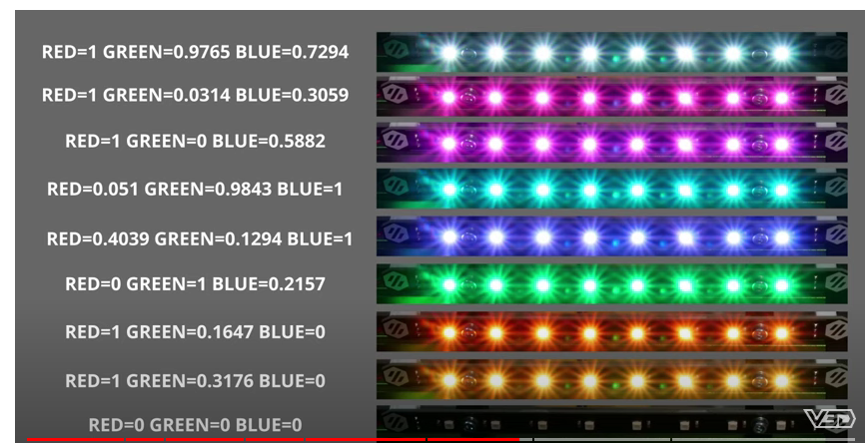

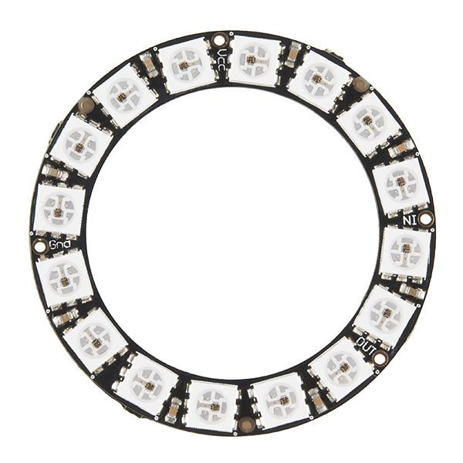

LEFT CENTER RIGHT

SCHEME:

**Power up Manta M8P wiring**

Green left ring lower and upper IN VCC GND PIN# .

Green first led center ring Left/Center Pink Red Brown PC6

Light red right ring Right Yellow Green Blue PA9

**Bed heat - lower left ring**

Yellow progress sequence during warm up

Red when at temp

**Extruder heat - upper left ring**

Yellow progress sequence during warm up

Red when at temp

**Print progress - center ring**

Blue progress sequence

**Failure - right ring**

Red flashing for errors

Red while extruder and bed are above 50C warning against a power shutdown

**1. Install:**

cd ~

git clone https://github.com/julianschill/klipper-led_effect.git

cd klipper-led_effect

./install-led_effect.sh

**2. Add to printer.cfg**

[include led_configuration.cfg]

[neopixel left]

pin: PC6

chain_count: 32

initial_red: 0

initial_green: 0

initial_blue: 0

[neopixel right]

pin: PA9

chain_count: 16

initial_red: 0

initial_green: 0.2

initial_blue: 0.2

**3. Create led_configuration.cfg:**

[led_effect panel_idle]

autostart: true

frame_rate: 24

leds:

neopixel:left (4,5,12,13)

layers:

breathing 10 0 top (.1,.2,0)

[led_effect power_idle]

autostart: true

frame_rate: 24

leds:

neopixel:right (1,3,5,7,9,11,13,15)

layers:

breathing 10 0 top (0.2,0.05,0.0)

[led_effect progress_idle]

autostart: true

frame_rate: 24

leds:

neopixel:left (17,32)

layers:

breathing 10 0 top (0.01,.01,.03)

[led_effect bed_effects]

leds:

neopixel:left (1-8)

neopixel:right (2,4,6,8,10,12,14,16)

autostart: true

frame_rate: 24

heater: heater_bed

layers:

heater 50 0 add (.1,0,0)

[led_effect extruder]

leds:

neopixel:left (9-16)

neopixel:right (2,4,6,8,10,12,14,16)

autostart: true

frame_rate: 24

heater: extruder

layers:

heater 50 0 add (.1,0,0)

[led_effect progress_bar]

leds:

neopixel:left (18-32)

autostart: true

frame_rate: 24

layers:

progress -1 0 add ( 0, 0, .1),( 0, 0.1, 0.6)

[led_effect critical_error]

leds:

neopixel:right (2,4,6,8,10,12,14,16)

layers:

strobe 1 1.5 add (1.0, 1.0, 1.0)

breathing 2 0 difference (0.95, 0.0, 0.0)

autostart: false

frame_rate: 24

run_on_error: true